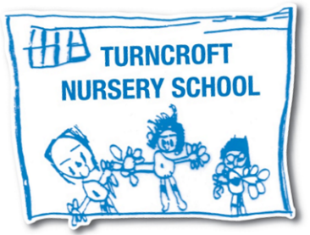
Turncroft Nursery School
Long Term Plan 2024-2025
Our curriculum follows the interests, fascinations and current needs of our children so may change as needs arise
 | Autumn 1 | Autumn 2 | Spring 1 | Spring 2 | Summer 1 | Summer 2
Key Learning  The ‘why’ | It’s Good to be Me!  To settle into routines and rules within the nursery. To develop relationships and confidence to access provision. To know who they are and who is part of their family | Let’s Celebrate  To develop an awareness and respect for a variety of festivals and celebrations | Superhero’s  To develop an understanding of different jobs and roles within our community. To know that we are all ‘super’ at different things | Traditional Tales  To develop  knowledge about seasonal changes- spring. To develop an awareness of stories that they can talk about | Bugs, Bugs, Bugs  To develop curiosity about animals and plants and their lifecycles | Sea Explorers  To develop an understanding of and curiosity about the sea and sea creatures
Core Texts | 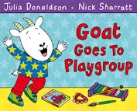  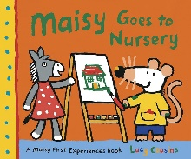  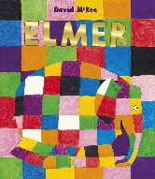 | 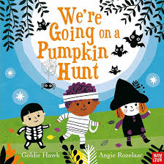  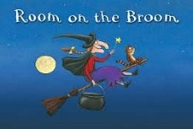  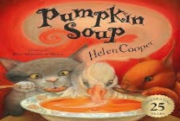 | 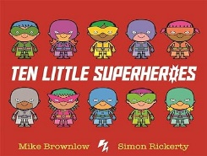  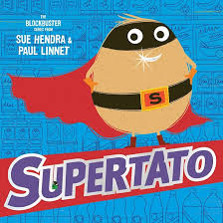  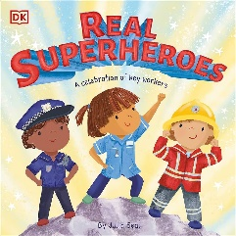 | 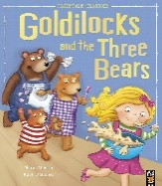  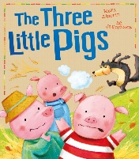  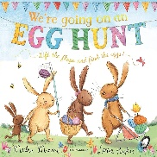 | 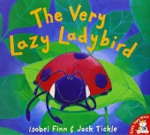  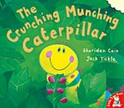  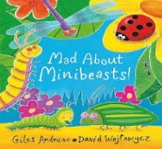 | 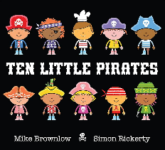  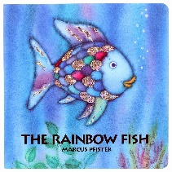  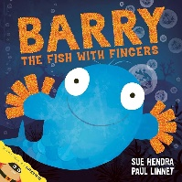
Core Rhymes | Heads, shoulders, knees and toes  Baa Baa lack sheep  Jack and Jill | Twinkle, twinkle little star  Hey diddle diddle  Humpty Dumpty | The wheels on the bus  Miss Polly had a dolly  The Grand Old Duke of York | Ten in a bed  I’m a little teapot  London Bridge | Mary, Mary Quite Contrary  Little Miss Muffet  Incy Wincy Spider | 1,2,3,4,5, once I caught a fish alive  Row, row, row your boat  Old MacDonald
Possible lines of enquiry | All about me  My family  Birthdays  Rules and routines  Feelings | Seasonal changes Autumn/Winter | Real life superheroes | Seasonal changes Spring | Life cycles planting and growing, butterfly life cycle | Visitors from the local community  Seasons- summer
Experiences | Starting nursery  Grandparents Day 5th October  Diwali 20th October | Nursery rhyme week (November)  Bonfire night  Bedtime stories night  Christmas Trail Day  Nativity performance  Christmas party | Day of love (14th February)  Visitors from a variety of occupations | Pancake Day 4th March  World Book Day 6th March  Eid-al-Fitr 30/31st March  Mother’s Day event 30th March  Easter | Sports Day  Visit from minibeast farm | Eid -al Adha 6th June  Father’s Day event 16th June  Pirate Party  Graduation  Transition  Sealife visit  Walk in the local community
Parental Involvement | Grandparents’ Day | Christmas Trail  Nativity  Parents meeting | Sponsored event | Mothers Day event  Parents meeting | Sports Day | Reports sent home  Transition  Graduation
Artist Links | Modrian Primary Colours | Jackson Pollock Firework  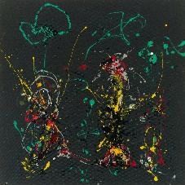 | Kandinsky  Circles  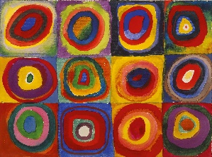 | Andy Goldworthy  Natural art  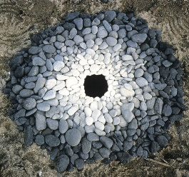 | Henri Mattise  Snail  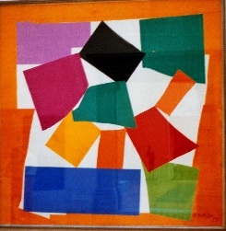 | John Kindness  Sculptor  Fish  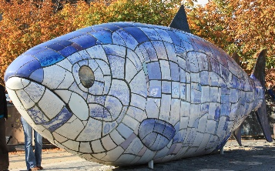
Other linked texts | Lu Lu loves nursery  Colour monster  Dogger  Books related to different feelings | Seasonal texts  Stick Man  Christmas and Nativity linked | Books about different occupations  Books about love | Easter story  Seasonal texts  Mr Wolf’s Pancakes | Jack and the Beanstalk  The Tiny Seed  Jaspers Beanstalk | Seasonal texts  Commotion in the Ocean  Seaside poems

 | Autumn 1 | Autumn 2 |  | Spring 1 | Spring 2 | Summer 1 | Summer 2
 | It’s Good to be Me! | Let’s Celebrate |  | Superhero’s | Traditional Tales | In the dark, dark woods | Sea Explorers
Personal, social and Emotional  PSED  Knowledge | I know the rules in nursery and I am beginning to follow them  I know how I am feeling and can talk about this  I know how to find resources and ask for help if I need it | I know how to play with others -sharing ideas  I know I feel safe in nursery and will talk/play with unfamiliar people  I know how to share and take turns |  | I know the rules and routines in nursery  I know how to be more comfortable in new situations as I feel safe | I know how to talk to others to solve a problem  I am beginning to know how someone is feeling – sad, happy, scared | I know how to be assertive in the correct manner  I know how to find a solution to a conflict or rivalry | I know that I am a member of a community- nursery, family, Darwen, squirrels
Development Matters links and School Readiness | Increasingly follow rules understanding why they are important  Talk about their feelings using words like, happy, sad, scared, angry  Select and use activities and resources with help when needed | Become more outgoing with unfamiliar people in the safe context of their setting  Play with one or more children, extending and elaborating play ideas |  | Remember rules without needing an adult to remind me  Show more confidence in new social situations | Talk with others to solve conflicts  Understand gradually how others may be feeling | Find solutions to conflicts and rivalries  Develop appropriate ways of being assertive | Develop their sense of responsibility and membership of a community
Vocabulary
Communication and Language  Knowledge | I know how to pronounce sound accurately  I know how to communicate, sometimes struggling with irregular tenses | I know how to answer a question with two parts  I know how to follow a two part instruction  I know how to concentrate on more than one thing at a time |  | I know a variety of songs and can sing them  I know how to speak in longer sentences of 4-6 weeks  I know and can listen to longer stories and remember what happens | I know vocabulary linked to a variety of topics I have explored  I know how to answer ‘why’ questions  I know how to take part in conversations many times | I know how to organise my play and myself  I know lots of rhymes  I know how to tell a long story  I know some familiar stories | I know my point of view on a topic and can explain this to others even when they disagree
Development Matters links and School Readiness | Develop their pronunciation but may have problems with some sounds; r,j,th,ch,sh  Develop communication sometimes having problems with irregular tenses | Pay attention to more than one thing at a time, which can be difficult  Understand a question or instruction that has two parts |  | Sing a large repertoire of songs  Enjoy listening to longer stories and can remember much of what happens  Use longer sentences of 4-6 words | Use a wider range of vocabulary  Understand ‘why’ questions  Can start a conversation with an adult or a friend and continue it for many turns | Use talk to organise themselves and their play  Know many rhymes, be able to talk about familiar books and be able to tell a long story | Be able to express a point of view and debate when they disagree with an adult or a friend
Vocabulary
Physical Development  Knowledge | I know how to make snips in paper  I know how to use large movements to paint, wave, swirl | I know how to skip, hop, stand on one leg  I know how to work with a friend  I know how to go up and down steps safely  I know how to use scissors to cut a straight line |  | I know how to keep my balance  I know how to use the toilet independently  I know how to get dressed and undressed  I know how to fasten my coat  I know how to cut along a wavy line | I know how to select resources to follow my plan  I know how to cut along a wavy line | I know which is my preferred hand  I know how to throw , kick and catch a large ball  I know how to cut around a shape  I know some healthy choices | I know what my comfortable grip is when mark making  I know how to make my own games and play them  I know how to cut around a shape
Development Matters links and School Readiness | Use one handed tools and equipment  Use large muscle movements to wave flags, streamers, paint | Go up steps and stairs or apparatus using alternative feet  I can demonstrate a range of physical skills, balance, ride, climb  Collaborate with others to move objects  Scissor skills cutting along a straight line Use one handed tools and equipment |  | Continue to develop movement and balancing, riding and ball skills  Be increasingly independent as I meet my own care needs I can put on an take off my coat, shoes, apron | Choose the right resources to carry out a plan  Match their developing physical skills to tasks and activities  Use one handed tools and equipment | Use one handed tools and equipment  Show a preference for a dominant hand  Make healthy choices  Increasingly able to use and remember sequences and patterns of movement with music and rhythm  I can do up my coat, with a zipper or poppers | Use one handed tools and equipment  Use a comfortable grip with good control  Take part in activities they make up for themselves
Vocabulary
Literacy  Knowledge | I know print goes from left to right and top to bottom  I know print has meaning  I know how to talk about stories | I know that pages go in order  I know a book has a front and back cover |  | I know a book has a title  I know how to talk about books and use new vocabulary  I know how to write some letters accurately | I know a book has an author and what they do  I know how to use my knowledge of letters in my early writing I know how to write some letters accurately | I know a book has an illustrator and what they do | I know a book has a blurb and what it is  I know how to write some or all of my name
Development Matters links and School Readiness | Engage in extended conversations about stories learning new vocabulary  Know that print has meaning and is read left to right, top to bottom | Sequence of pages  Know where the front and back cover of a book is |  | Use some of their print and letter knowledge in their early writing |  |  | Write some or all of their name
Develop their phonological awareness so they can:
Suggest a missing word in a nursery rhyme
Count or clap syllables in a word
Recognise words with the same initial sound
Understand the five key concepts about print:
Print has meaning
Print can have different purposes
We read English from left to right, top to bo9ttom
The names of different parts of a book
Page sequencing

Vocabulary
Phonics | Aspect 1 Environmental sounds: Tuning into sounds  Aspect 2 Instrumental sounds: Tuning into sounds  Aspect 3 Body percussion: Tuning into sounds  Action rhymes | Aspect 1 Environmental sounds  Aspect 2 Instrumental sounds  Aspect 3 Body percussion  Strands-Listening and remembering sounds, Talking about sounds  Using instruments |  | Aspect 4 Rhythm and Rhyme  Aspect 5 Alliteration Tuning into sounds Listening and remembering sounds  Rhyming Stories | Aspect 4 Rhythm and Rhyme  Aspect 5 Alliteration Tuning into sounds Listening and remembering sounds  Talking about sounds Tongue twisters  Keeping a steady beat | Aspect 6 Voice sounds  Aspect 7 oral segmenting and blending  Tuning into sounds  Listening and remembering sounds | Aspect 6 Voice sounds  Aspect 7 oral segmenting and blending  Listening and remembering sounds  Talking about sounds
Mathematics  Knowledge | I know a variety of colours and can match and sort them  I know how to talk about objects relating to size  I know some 2D shapes and can talk about them | I know how to recognise 3 objects without counting- subitising  I know how to say one number for each in order 1,2,3,4,5  I know and can show finger numbers to 5  I know the last number reached is the total  I know how to extend create ABAB patterns and correct an error |  | I know how to say number s in order 1,2,3,4,5  I know and can show finger numbers to 5  I know some 2D and 3D shapes and can talk about them  I know how to recognise 3 objects without counting- subitising | I kno9w how to recite past 5  I know the last number reached is the total  I know some amounts and can match them to the correct numeral  I know and can compare objects- size, weight, length, capacity | I know how to talk about a sequence of events- first, then  I know position words and can follow these  I know how to compare quantities, more than, fewer than  I know 2D and 3D shapes and can talk about them | I know how to recite numbers past 5  I know the last number reached is the total  I know how to solve real world problems to 5
Development Matters links and School Readiness | Explore colour and sort, categorise and match  Make comparisons between objects relating to size  Complete inset puzzles  Compare sizes, bigger, smaller  Talk about and explore 2D shapes using informal and mathematical language | Develop fast recognition of upto 3 objects without counting-subitising  Say one number for each item in order 1,2,3,4,5  Show finger numbers |  | Develop fast recognition of upto 3 objects without counting-subitising Say one number for each item in order 1,2,3,4,5  Know that the last number reached when counting a small set of objects tells you how many there are in total-cardinal principle  Link numerals to amounts  Experiment with own symbols and marks as well as numerals  Talk about and explore 2D and 3D shapes using mathematical and informal language | Know that the last number reached when counting a small set of objects tells you how many there are in total-cardinal principle  Recite numbers past 5  Link numerals to amounts  Make comparisons between objects relating to size, length, weight and capacity | Begin to describe a sequence of events, first, next, then  Understand positi9on through words alone  Compare quantities- more then, less than  Talk about and explore 2D and 3D shapes using mathematical and informal language | Recite numbers past 5  Know that the last number reached when counting a small set of objects tells you how many there are in total-cardinal principle  Link numerals and amounts  Solve real world problems with numbers to 5
Maths Rhymes linked | 1,2,3,4,5, once I caught a fish alive  1 potato  5 little speckled frogs  5 little ducks  5 currant buns  5 sausages |  | 1 finger, 1 thumb  1, 2 Buckle my shoe  2 little dickie birds  Head, shoulders, knees and toes  Zoom, zoom, zoom | Three blind mice  Three little kittens  5 snowmen  4 teddy bears  5 fingers  Alice the camel | Sing a song of sixpence  When Goldilocks came to the house of the bears  I’m a little bean  5 cheeky monkeys swinging in the trees | One big hippo  Sleeping bunnies  5 cheeky monkeys jumping on the bed  5 little apples | 5 little men in a flying saucer  Humpty Dumpty  One elephant went out to play  Ring a roses  London Bridge is falling down
Understanding the World  Knowledge | I know how old I am  I know who is in my family and I can talk about them  I know how to use my senses when exploring materials | I know some different materials  I know and can talk about how materials change |  | I know and can talk about forces that I feel- magnets, pushing and pulling  I know about some different jobs  I know that we are not all the same | I know and can talk about different materials using a variety of words | I know how to plant and take care of plants  I know the features of a lifecycle- plant/butterfly  I know how to care for the world around me | I know that there are different countries in the world  I know some differences about some countries
Development Matters links and School Readiness | Begin to make sense of their own life story and family history  Use all of their senses in hands on exploration of natural materials  Lifecycles- human- how old am I? | Talk about the differences between materials and changes that they notice  Explore how things work |  | Explore and talk about forces they can feel  Show an interest in different occupations  Continue developing positive attitudes about differences between people | Explore collections of materials with similar and different properties  Talk about what they see using a wide range of vocabulary | Plant seeds and care for growing plants  Begin to understand the need to respect and care for the natural environment and all living things  Understand the features of a life cycle plant/butterfly | Can talk about family, community and wider experiences  Explore how things work
Expressive Arts and Design  Knowledge | I know how to show emotions-sad, happy etc through my art  I know how to play and use different objects to represent something in my play | I know how to talk about what I see and hear  I know how to play instruments with increasing control- including those I have made  I know how to sing some familiar songs |  | I know and can remember entire songs  I know how to listen carefully to sounds  I know how to draw closed shapes with continuous lines to represent objects  I know how to print with different shapes | I know there are different materials and can explore using them  I know how to use small world to make up my own stories | I know how to add detail to my drawings  I know how to join materials and use different textures  I know how to create and build in small world | I know how to make my own songs using those I know  I know my own ideas and can try them out using different materials- masks, clay, Modroc linked to sculptor John Kindness
Development Matters links and School Readiness | Show different emotions in their drawing and painting Experiment with colour mixing, paint with different parts of the body  Take part in simple pretend play, using an object to represent something else | Use drawings to represent ideas like movement and loud noises- linked to artist  Respond to what they see and hear expressing their thoughts and feelings  Sing the melodic shape of familiar songs |  | Remember and sing a few songs and/or rhymes  Listen with increased attention to sounds  Create closed shapes with continuous lines- use these to represent objects | Sing the pitch of a tone sung by another person- pitch match  Explore materials freely to develop their ideas about how to use them and what to make- link to artist Andy Goldsworthy natural materials  Begin to develop complex stories using small world | Draw with increasing complexity and detail  Join different materials and explore different textures  Make imaginative and complex small worlds with blocks and construction sets | Create their own songs or improvise a song around one they know  Develop own ideas and then decide which materials to use to express them
Vocabulary

